Host et al. Copper River Sockeye Fitness-Associated Traits
Supplementary Material

Supplementary Figures

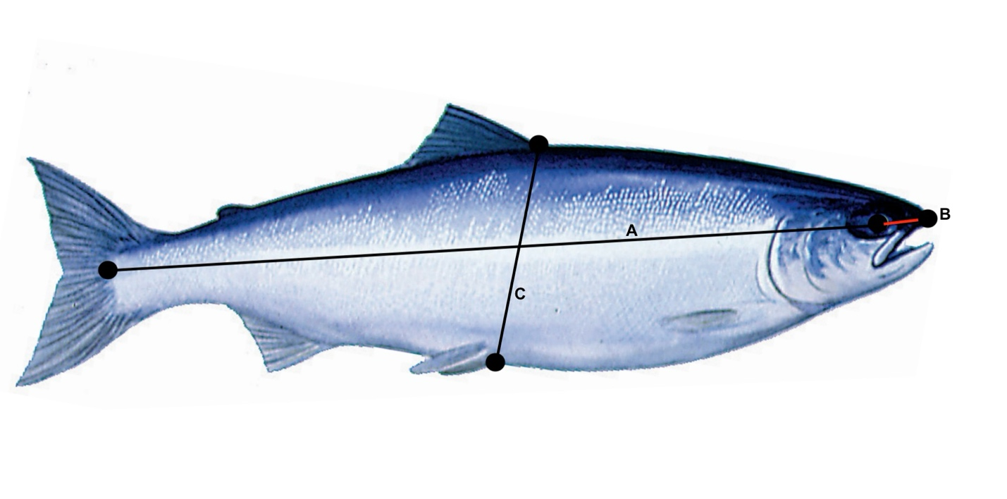
Figure S1. Copper River sockeye salmon body measurements where A (body length) is mid-eye to hypural (±1 mm), B (head length) is mid-eye to snout/kype (±1 mm), and C (body height) is anterior dorsal to anterior pelvic (±1 mm).

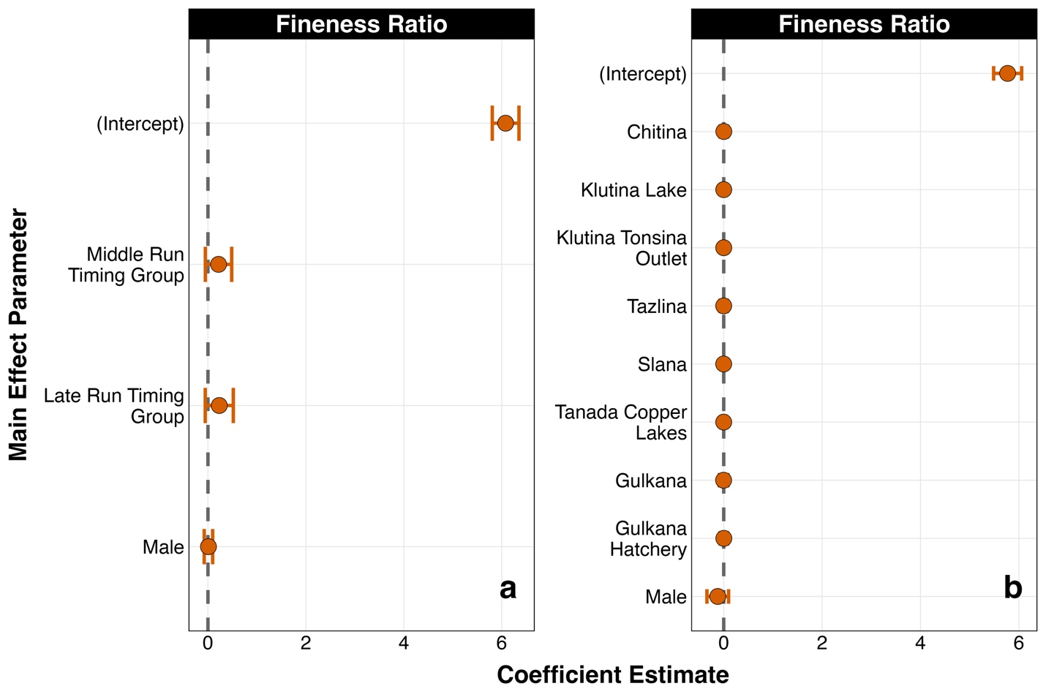

Figure S2. Model-averaged parameter estimates and associated 95% confidence intervals for main effects included in candidate model sets examining variation in fineness ratio among (a) seasonal run timing groups (2019-2021) and (b) genetic populations (2020-21) of sockeye salmon returning to the Copper River, Alaska during early migration.

Note: Fineness ratio was calculated as fish length divided by maximum body width. Main effect parameter estimates reported are all relative to the intercept. The intercept values for each escapement quality metric represents the reference parameter estimate for (a) Early Run Timing and female sockeye and (b) Bremner and female sockeye.

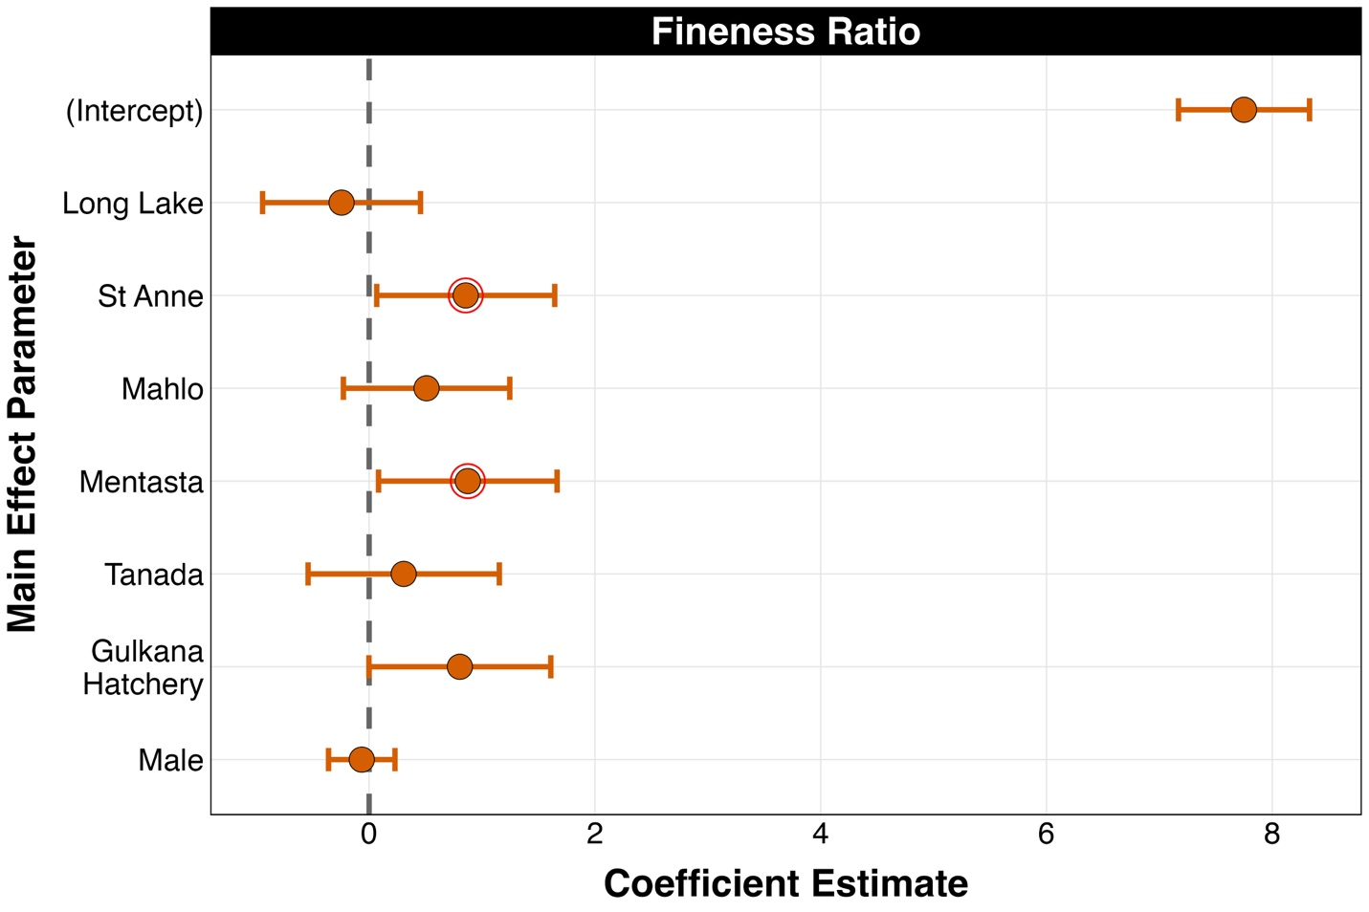

Figure S3. Model-averaged parameter estimates and associated 95% confidence intervals for main effects included in candidate model sets examining variation in fineness ratio among spawning populations of sockeye salmon returning to the Copper River, Alaska (2019-2021).

Note: Fineness ratio was calculated as fish length divided by maximum body width. Parameter estimates circled in red have confidence intervals that do not overlap zero, indicating support for an effect on the response variable. Main effect parameter estimates reported are all relative to the intercept. The intercept value for fineness ratio represents the reference parameter estimate for Fish Creek Gulkana and female sockeye.

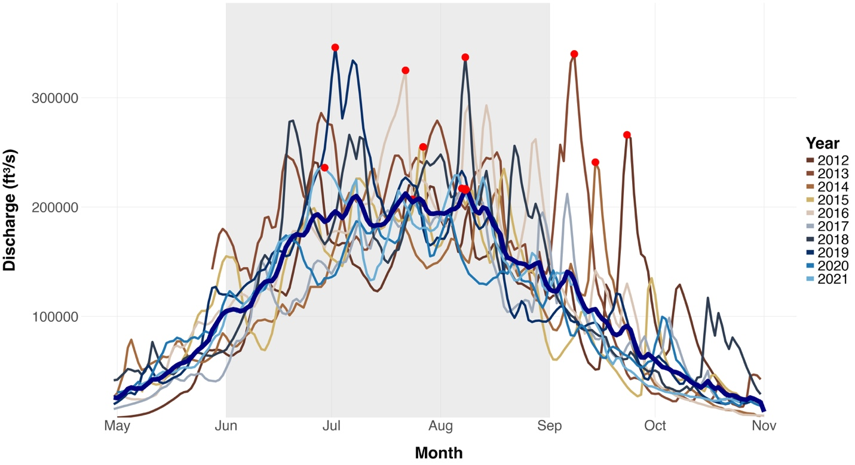
Figure S4. Annual discharge patterns for the Copper River, Alaska from May 1 to November 1, 2012-2021. The decadal average discharge rate is noted by the bold navy blue line. Data were obtained from the US Geological Survey (USGS 2025) monitoring station at the Million Dollar Bridge (site 15214000, Cordova, Alaska). Red points note the peak discharge values (cubic feet per second, ft³ s⁻¹) for each year, while the grey box is the collection period in the current study for sockeye salmon returning to the Copper River watershed (early June - early September, 2019-2021 only).

Supplementary Tables
Table S1. Least-squares general linear candidate model set for explaining variation in body size (PC1 score) for run timing groups of sockeye salmon returning to the Copper River, Alaska (2019–2021) during early migration.
Model Number | Response Variable | Explanatory Variables
1 | PC1 score | ~1 (null model)
2 | PC1 score | ~Collection River Mile + Run Timing Group
3 | PC1 score | ~Collection River Mile + Sex
4 | PC1 score | ~Collection River Mile + Year
5 | PC1 score | ~Collection River Mile + Run Timing Group + Sex
6 | PC1 score | ~Collection River Mile + Run Timing Group + Year
7 | PC1 score | ~Collection River Mile + Sex + Year
8 | PC1 score | ~Collection River Mile + Run Timing Group + Sex + Run Timing Group x Sex
9 | PC1 score | ~Collection River Mile + Year + Sex + Year x Sex
10 | PC1 score | ~ Collection River Mile + Run Timing Group + Sex + Year (global model)

Note: PC1 score represents a composite index derived from principal component analysis of mid-eye to hypural length, body height, and body girth.

Table S2. Least-squares general linear candidate model set used to explain variation in fineness ratio among seasonal run timing groups of sockeye salmon returning to the Copper River watershed, Alaska, during early migration (2019–2021).
Model Number | Response Variable | Explanatory Variables
1 | Fineness Ratio | ~1 (null model)
2 | Fineness Ratio | ~Collection River Mile + Run Timing Group
3 | Fineness Ratio | ~Collection River Mile + Sex
4 | Fineness Ratio | ~Collection River Mile + Run Timing Group + Sex  (global model)

Note: Fineness ratio was calculated as fish length divided by maximum body width. Candidate models to assess variation in fineness ratio for run timing groups were constructed based on results from body size.

Table S3. Least-squares general linear candidate model set for explaining variation in somatic energy density (MJ/g) for run timing groups of sockeye salmon returning to the Copper River, Alaska (2019–2021) during early migration.

Model Number | Response Variable | Explanatory Variables
1 | Somatic Energy Density | ~1 (null model)
2 | Somatic Energy Density | ~Collection River Mile + Run Timing Group
3 | Somatic Energy Density | ~Collection River Mile + Sex
4 | Somatic Energy Density | ~Collection River Mile + Year
5 | Somatic Energy Density | ~Collection River Mile + Run Timing Group + Sex
6 | Somatic Energy Density | ~Collection River Mile + Run Timing Group + Year
7 | Somatic Energy Density | ~Collection River Mile + Sex + Year
8 | Somatic Energy Density | ~Collection River Mile + Run Timing Group + Sex + Run Timing Group x Sex
9 | Somatic Energy Density | ~Collection River Mile + Year + Sex + Year x Sex
10 | Somatic Energy Density | ~ Collection River Mile + Run Timing Group + Sex + Year (global model)

Note: Somatic energy density was estimated from bomb calorimetry of viscera-free somatic tissue.

Table S4. Least-squares general linear candidate model set for explaining variation in total somatic energy (MJ) for run timing groups of sockeye salmon returning to the Copper River, Alaska (2019–2021) during early migration.

Model Number | Response Variable | Explanatory Variables
1 | Total Somatic Energy | ~1 (null model)
2 | Total Somatic Energy | ~Collection River Mile + Run Timing Group
3 | Total Somatic Energy | ~Collection River Mile + Sex
4 | Total Somatic Energy | ~Collection River Mile + Year
5 | Total Somatic Energy | ~Collection River Mile + Run Timing Group + Sex
6 | Total Somatic Energy | ~Collection River Mile + Run Timing Group + Year
7 | Total Somatic Energy | ~Collection River Mile + Sex + Year
8 | Total Somatic Energy | ~Collection River Mile + Run Timing Group + Sex + Run Timing Group x Sex
9 | Total Somatic Energy | ~Collection River Mile + Year + Sex + Year x Sex
10 | Total Somatic Energy | ~ Collection River Mile + Run Timing Group + Sex + Year (global model)

Note: Somatic energy density was estimated from bomb calorimetry of viscera-free somatic tissue multiplied by viscera-free carcass weight yielding total somatic energy.

Table S5. Least-squares general linear candidate model set for explaining variation in female fecundity for run timing groups of sockeye salmon returning to the Copper River, Alaska (2019–2021) during early migration.
Model Number | Response Variable | Explanatory Variables
1 | Fecundity | ~1 (null model)
2 | Fecundity | ~Collection River Mile + PC1 Score
3 | Fecundity | ~Collection River Mile + Energy Density
4 | Fecundity | ~Collection River Mile + Run Timing Group
5 | Fecundity | ~Collection River Mile + Year
6 | Fecundity | ~Collection River Mile + PC1 Score + Energy Density
7 | Fecundity | ~Collection River Mile + PC1 Score + Run Timing Group
8 | Fecundity | ~Collection River Mile + PC1 Score + Year
9 | Fecundity | ~Collection River Mile + Energy Density + Run Timing Group
10 | Fecundity | ~Collection River Mile + Energy Density + Run Timing Group + Energy Density x Run Timing Group
11 | Fecundity | ~Collection River Mile + Energy Density + Year
12 | Fecundity | ~Collection River Mile + Run Timing Group + Year
13 | Fecundity | ~Collection River Mile + PC1 Score + Energy Density + Run Timing Group
14 | Fecundity | ~Collection River Mile + PC1 Score + Energy Density + Year
15 | Fecundity | ~Collection River Mile + PC1 Score + Run Timing Group + Year
16 | Fecundity | ~Collection River Mile + Energy Density + Run Timing Group + Year
17 | Fecundity | ~Collection River Mile + PC1 Score + Energy Density + Run Timing Group + Year  (global model)

Note: Fecundity was determined as the number of eggs in the subsample divided by the weight of that same subsample (g).

Table S6. Least-squares general linear candidate model set for explaining variation in body size (PC1 score) for genetic populations of sockeye salmon returning to the Copper River, Alaska (2020–2021) during early migration.

Model Number | Response Variable | Explanatory Variables
1 | PC1 score | ~1 (null model)
2 | PC1 score | ~Collection River Mile + Genetic Population
3 | PC1 score | ~Collection River Mile + Sex
4 | PC1 score | ~Collection River Mile + Genetic Population + Sex  (global model)

Note: PC1 score represents a composite index derived from principal component analysis of mid-eye to hypural length (mm), body height (mm) and body girth (mm).

Table S7. Least-squares general linear candidate model set used to explain variation in fineness ratio among genetic populations of sockeye salmon returning to the Copper River watershed, Alaska, during early migration (2020–2021).
Model Number | Response Variable | Explanatory Variables
1 | Fineness Ratio | ~1 (null model)
2 | Fineness Ratio | ~Collection River Mile + Genetic Population
3 | Fineness Ratio | ~Collection River Mile + Sex
4 | Fineness Ratio | ~Collection River Mile + Genetic Population + Sex  (global model)

Note: Fineness ratio was calculated as fish length divided by maximum body width. Candidate models to assess variation in fineness ratio for genetic populations were constructed based on results from body size.

Table S8. Least-squares general linear candidate model set for explaining variation in somatic energy density (MJ/g) for genetic populations of sockeye salmon returning to the Copper River, Alaska (2020–2021) during early migration.

Model Number | Response Variable | Explanatory Variables
1 | Somatic Energy Density | ~1 (null model)
2 | Somatic Energy Density | ~Collection River Mile + Genetic Population
3 | Somatic Energy Density | ~Collection River Mile + Sex
4 | Somatic Energy Density | ~Collection River Mile + Genetic Population + Sex  (global model)

Note: Somatic energy density was estimated from bomb calorimetry of viscera-free somatic tissue.

Table S9. Least-squares general linear candidate model set for explaining variation in total somatic energy (MJ) for genetic populations of sockeye salmon returning to the Copper River, Alaska (2020–2021) during early migration.

Model Number | Response Variable | Explanatory Variables
1 | Total Somatic Energy | ~1 (null model)
2 | Total Somatic Energy | ~Collection River Mile + Genetic Population
3 | Total Somatic Energy | ~Collection River Mile + Sex
4 | Total Somatic Energy | ~Collection River Mile + Genetic Population + Sex  (global model)

Note: Somatic energy density was estimated from bomb calorimetry of viscera-free somatic tissue multiplied by viscera-free carcass weight yielding total somatic energy.

Table S10. Least-squares general linear candidate model set for explaining variation in female fecundity for genetic populations of sockeye salmon returning to the Copper River, Alaska (2020–2021) during early migration.
Model Number | Response Variable | Explanatory Variables
1 | Fecundity | ~1 (null model)
2 | Fecundity | ~Collection River Mile + PC1 Score
3 | Fecundity | ~Collection River Mile + Energy Density
4 | Fecundity | ~Collection River Mile + Genetic Population
5 | Fecundity | ~Collection River Mile + PC1 Score + Energy Density
6 | Fecundity | ~Collection River Mile + PC1 Score + Genetic Population
7 | Fecundity | ~Collection River Mile + Energy Density + Genetic Population
8 | Fecundity | ~Collection River Mile + PC1 Score + Energy Density + Genetic Population  (global model)

Note: Fecundity was determined as the number of eggs in the subsample divided by the weight of that same subsample (g).

Table S11. Least-squares general linear candidate model set for explaining variation in body size (PC1 score) among spawning populations of post-migration sockeye salmon returning to the Copper River, Alaska (2019–2021).

Model Number | Response Variable | Explanatory Variables
1 | PC1 score | ~1 (null model)
2 | PC1 score | ~Gonad Weight + Spawning Population
3 | PC1 score | ~Gonad Weight + Sex
4 | PC1 score | ~Gonad Weight + Year
5 | PC1 score | ~Gonad Wight + Spawning Population + Sex
6 | PC1 score | ~Gonad Wight + Spawning Population + Year
7 | PC1 score | ~Gonad Wight + Sex + Year
8 | PC1 score | ~Gonad Wight + Spawning Population + Sex + Spawning Population x Sex
9 | PC1 score | ~Gonad Wight + Sex + Year + Sex x Year
10 | PC1 score | ~Gonad Wight + Spawning Population + Sex + Year  (global model)

Note: PC1 score represents a composite index derived from principal component analysis of mid-eye to hypural length (mm), body height (mm) and body girth (mm).

Table S12. Least-squares general linear candidate model set used to explain variation in fineness ratio among spawning populations of post-migration sockeye salmon returning to the Copper River watershed, Alaska (2019–2021).
Model Number | Response Variable | Explanatory Variables
1 | Fineness Ratio | ~1 (null model)
2 | Fineness Ratio | ~Gonad Weight + Spawning Population
3 | Fineness Ratio | ~Gonad Weight + Sex
4 | Fineness Ratio | ~Gonad Weight + Spawning Population + Sex  (global model)

Note: Fineness ratio was calculated as fish length divided by maximum body width. Candidate models to assess variation in fineness ratio for spawning populations were constructed based on results from body size.

Table S13. Least-squares general linear candidate model set for explaining variation in somatic energy density (MJ/g) among spawning populations of post-migration sockeye salmon returning to the Copper River, Alaska (2019–2021).

Model Number | Response Variable | Explanatory Variables
1 | Somatic Energy Density | ~1 (null model)
2 | Somatic Energy Density | ~Gonad Weight + Spawning Population
3 | Somatic Energy Density | ~Gonad Weight + Sex
4 | Somatic Energy Density | ~Gonad Weight + Year
5 | Somatic Energy Density | ~Gonad Wight + Spawning Population + Sex
6 | Somatic Energy Density | ~Gonad Wight + Spawning Population + Year
7 | Somatic Energy Density | ~Gonad Wight + Sex + Year
8 | Somatic Energy Density | ~Gonad Wight + Spawning Population + Sex + Spawning Population x Sex
9 | Somatic Energy Density | ~Gonad Wight + Sex + Year + Sex x Year
10 | Somatic Energy Density | ~Gonad Wight + Spawning Population + Sex + Year  (global model)

Note: Somatic energy density was estimated from bomb calorimetry of viscera-free somatic tissue.

Table S14. Least-squares general linear candidate model set for explaining variation in total somatic energy (MJ) among spawning populations of post-migration sockeye salmon returning to the Copper River, Alaska (2019–2021).

Model Number | Response Variable | Explanatory Variables
1 | Total Somatic Energy | ~1 (null model)
2 | Total Somatic Energy | ~Gonad Weight + Spawning Population
3 | Total Somatic Energy | ~Gonad Weight + Sex
4 | Total Somatic Energy | ~Gonad Weight + Year
5 | Total Somatic Energy | ~Gonad Wight + Spawning Population + Sex
6 | Total Somatic Energy | ~Gonad Wight + Spawning Population + Year
7 | Total Somatic Energy | ~Gonad Wight + Sex + Year
8 | Total Somatic Energy | ~Gonad Wight + Spawning Population + Sex + Spawning Population x Sex
9 | Total Somatic Energy | ~Gonad Wight + Sex + Year + Sex x Year
10 | Total Somatic Energy | ~Gonad Wight + Spawning Population + Sex + Year  (global model)

Note: Somatic energy density was estimated from bomb calorimetry of viscera-free somatic tissue multiplied by viscera-free carcass weight yielding total somatic energy.

Table S15. Least-squares general linear candidate model set for explaining variation in egg size (mm) among spawning populations of post-migration sockeye salmon returning to the Copper River, Alaska (2019–2021).

Model Number | Response Variable | Explanatory Variables
1 | Egg Size | ~1 (null model)
2 | Egg Size | ~Gonad Weight + PC1 Score
3 | Egg Size | ~Gonad Weight + Energy Density
4 | Egg Size | ~Gonad Weight + Spawning Population
5 | Egg Size | ~Gonad Weight + Year
6 | Egg Size | ~Gonad Weight + PC1 Score + Energy Density
7 | Egg Size | ~Gonad Weight + PC1 Score + Spawning Population
8 | Egg Size | ~Gonad Weight + PC1 Score + Year
9 | Egg Size | ~Gonad Weight + Energy Density + Spawning Population
10 | Egg Size | ~Gonad Weight + Energy Density + Spawning Population + Energy Density x Spawning Population
11 | Egg Size | ~Gonad Weight + Energy Density + Year
12 | Egg Size | ~Gonad Weight + Spawning Population + Year
13 | Egg Size | ~Gonad Weight + PC1 Score + Energy Density + Spawning Population
14 | Egg Size | ~Gonad Weight + PC1 Score + Energy Density + Year
15 | Egg Size | ~Gonad Weight + PC1 Score + Spawning Population + Year
16 | Egg Size | ~Gonad Weight + Energy Density + Spawning Population + Year
17 | Egg Size | ~Gonad Weight + PC1 Score + Energy Density + Spawning Population + Year  (global model)

Note: Egg size was estimated as mean egg diameter, calculated by summing the diameters of 10 eggs per sub-sample and dividing by 10.

Table S16. Migratory difficulty for Copper River, Alaska, sockeye salmon, calculated as Migratory Work (km²; upstream distance x elevation of location) for unique genetic populations sampled during early migratory collections (2020-2021) and spawning ground populations sampled during post-migratory collections (2019-2021).

Collection Type | Population / Location | Distance  (m) | Elevation  (m) | Work  (km²)
Early Migratory | Bremner | 110272.14 | 76 | 8.38
 | Chitina Long Lake | 258752.38 | 430 | 111.26
 | Chitina Tana River | 336321.99 | 443 | 148.99
 | Chitina Tebay | 211015.06 | 199 | 41.99
 | Chitina |  |  | 100.75
 | Klutina Lake Outlet | 303320.71 | 527 | 159.85
 | Tonsina Lake Outlet | 281186.18 | 575 | 161.68
 | Klutina Tonsina Lake Outlet |  |  | 160.77
 | Klutina St. Anne | 319323.05 | 531 | 169.56
 | Klutina Mahlo | 306987.7 | 537 | 164.85
 | Klutina Lake Outlet | 303320.71 | 527 | 159.85
 | Klutina Banana Lake | 352573.7 | 578 | 203.79
 | Klutina Lake |  |  | 174.51
 | Tazlina | 419947.86 | 704 | 295.64
 | Gulkana Keg Creek | 479710.38 | 724 | 347.31
 | Gulkana Paxson outlet | 437517.99 | 780 | 341.26
 | Gulkana Swede Lake | 475611.7 | 854 | 406.17
 | Gulkana Fish Creek | 473968.02 | 988 | 468.28
 | Gulkana |  |  | 390.76
 | Gulkana Hatchery | 468383.14 | 909 | 425.76
 | Tanada | 472343.24 | 887 | 418.97
 | Slana Bad Crossing 2 | 503369.07 | 903 | 454.54
 | Slana Bone Creek | 489493 | 786 | 384.74
 | Slana Mentasta | 472102.04 | 678 | 320.09
 | Slana Suslota | 451568.68 | 811 | 366.22
 | Slana |  |  | 381.40
Post-Migratory | Long Lake | 258752.38 | 430 | 111.26
 | St. Anne | 319323.05 | 531 | 169.56
 | Mahlo | 306987.7 | 537 | 164.85
 | Gulkana Hatchery | 468383.14 | 909 | 425.76
 | Slana Mentasta | 472102.04 | 678 | 320.09
 | Tanada | 472343.24 | 887 | 418.97
 | Fish Creek | 473968.02 | 988 | 468.28

Note: Upstream distances (m) were calculated from our Copper River delta starting point (60.27 °N, -145.07 °W) to genetic population baseline spawning sites and locations of spawning ground collections. For genetic populations, all baseline populations are included, and the name listed in bold is the average work value calculated for that overall genetic population.

Table S17. Summary of body size and shape, and energy content (a-d) among life history groups of return migrating sockeye salmon collected from the mainstem Copper River, Alaska, during early migration (2019–2021).

Analysis | Response Variable | Parameter | Parameter Estimate (± 1 SE) | Parameter Likelihood
Seasonal Run Timing | a) Body size (PC1 score) | Early run timing  Middle run timing | 0.55 ± 0.58  -0.17 ± 0.27 | 0.99  0.99
 |  | Late run timing | -0.44 ± 0.33 | 0.99
 |  | Female | 0.55 ± 0.58 | 0.99
 |  | Male | 1.30 ± 0.25 | 0.99
 |  | 2019 | 0.55 ± 0.58 | 0.65
 |  | 2020 | 0.35 ± 0.30 | 0.65
 |  | 2021 | 0.79 ± 0.40 | 0.65
 | b) Fineness Ratio | Early run timing | 6.08 ± 0.14 | 1.00
 |  | Middle run timing | 6.30 ± 0.14 | 0.88
 |  | Late run timing | 6.31 ± 0.15 | 0.88
 |  | Female | 6.08 ± 0.14 | 0.13
 |  | Male | 6.09 ± 0.0044 | 0.13
 | c) Somatic Energy Density (MJ/g) | Early run timing  Middle run timing | 0.011 ± 4.23E-04  0.011 ± 1.63E-04 | 1.00  1.00
 |  | Late run timing | 0.010 ± 1.93E-04 | 1.00
 |  | Female | 0.011 ± 4.23E-04 | 0.27
 |  | Male | 0.011 ± 7.27E-05 | 0.27
 |  | 2019 | 0.011 ± 4.23E-04 | 1.00
 |  | 2020 | 0.011 ± 2.11E-04 | 1.00
 |  | 2021 | 0.010 ± 2.85E-04 | 1.00
 | d) Total Somatic Energy (MJ) | Early run timing  Middle run timing | 19.67 ± 1.22  18.64 ± 0.86 | 0.94  0.94
 |  | Late run timing | 17.31 ± 1.08 | 0.94
 |  | Female | 19.67 ± 1.22 | 1.00
 |  | Male | 22.56 ± 0.75 | 1.00
 |  | 2019 | 19.67 ± 1.22 | 0.13
 |  | 2020 | 19.58 ± 0.46 | 0.13
 |  | 2021 | 19.65 ± 0.54 | 0.13

Note: Body size (PC1 score) represents a composite index derived from principal component analysis of mid-eye to hypural length, body height, and body girth. Somatic energy metrics were estimated from bomb calorimetry of viscera-free somatic tissue. Fineness ratio was calculated as fish length divided by maximum body width. Parameter estimates are presented as means ±1 standard error (SE). Collection river mile was included as an explanatory variable in all candidate models to account for sampling location effects and is not reported.

Table S18. Summary of body size, energy content, and biomechanical shape (a-d) among genetic populations of return migrating sockeye salmon collected from the mainstem Copper River, Alaska, during early migration (2020–2021).

Analysis | Response Variable | Parameter | Parameter Estimate (± 1 SE) | Parameter Likelihood
Genetic Population | a) Body Size (PC1 Score) | Bremner  Chitina | 0.44 ± 0.61  0.82 ± 0.78 | 0.23  0.23
 |  | Klutina Tonsina Outlet | 0.69 ± 0.60 | 0.23
 |  | Klutina Lake | 0.69 ± 0.55 | 0.23
 |  | Tazlina | 0.31 ± 0.55 | 0.23
 |  | Slana | 0.57 ± 0.43 | 0.23
 |  | Tanada Copper Lakes | 0.93 ± 0.96 | 0.23
 |  | Gulkana | 0.65 ± 0.64 | 0.23
 |  | Gulkana Hatchery | 0.80 ± 0.74 | 0.23
 |  | Female | 0.44 ± 0.61 | 0.95
 |  | Male | 1.15 ± 0.34 | 0.95
 | b) Fineness Ratio | Bremner | 5.77 ± 0.14 | 0.00084
 |  | Chitina | 5.77 ± 0.04 | 0.00084
 |  | Klutina Tonsina Outlet | 5.77 ± 0.03 | 0.00084
 |  | Klutina Lake | 5.77 ± 0.02 | 0.00084
 |  | Tazlina | 5.77 ± 0.04 | 0.00084
 |  | Slana | 5.77 ± 0.03 | 0.00084
 |  | Tanada Copper Lakes | 5.77 ± 0.03 | 0.00084
 |  | Gulkana | 5.77 ± 0.04 | 0.00084
 |  | Gulkana Hatchery | 5.77 ± 0.04 | 0.00084
 |  | Female | 5.77 ± 0.14 | 1.00
 |  | Male | 5.75 ± 0.11 | 1.00
 | c) Somatic Energy Density (MmJ/g) | Bremner  Chitina | 0.0092 ± 4.34E-04  0.010 ± 4.95E-04 | 1.00  1.00
 |  | Klutina Tonsina Outlet | 0.0099 ± 5.07E-04 | 1.00
 |  | Klutina Lake | 0.010 ± 4.20E-04 | 1.00
 |  | Tazlina | 0.011 ± 6.62E-04 | 1.00
 |  | Slana | 0.010 ± 4.75E-04 | 1.00
 |  | Tanada Copper Lakes | 0.011 ± 4.88E-04 | 1.00
 |  | Gulkana | 0.011 ± 6.69E-04 | 1.00
 |  | Gulkana Hatchery | 0.011 ± 4.51E-04 | 1.00
 |  | Female | 0.0092 ± 4.34E-04 | 0.50
 |  | Male | 0.0091 ± 1.97E-04 | 0.50
 | d) Total Somatic Energy (MmJ) | Bremner  Chitina | 15.09 ± 1.78  23.90 ± 2.15 | 1.00  1.00
 |  | Klutina Tonsina Outlet | 18.50 ± 2.09 | 1.00
 |  | Klutina Lake | 18.70 ± 1.73 | 1.00
 |  | Tazlina | 16.53 ± 2.72 | 1.00
 |  | Slana | 18.22 ± 1.95 | 1.00
 |  | Tanada Copper Lakes | 23.66 ± 1.99 | 1.00
 |  | Gulkana | 19.68 ± 2.75 | 1.00
 |  | Gulkana Hatchery | 22.14 ± 1.83 | 1.00
 |  | Female | 15.09 ± 1.78 | 1.00
 |  | Male | 17.73 ± 0.84 | 0.99

Note: Body size (PC1 score) represents a composite index derived from principal component analysis of mid-eye to hypural length, body height, and body girth. Somatic energy metrics were estimated from bomb calorimetry of viscera-free somatic tissue. Fineness ratio was calculated as fish length divided by maximum body width. Parameter estimates are presented as means ±1 standard error (SE). Collection river mile was included as an explanatory variable in all candidate models to account for sampling location effects and is not reported.

Table S19. Summary of reproductive quality metrics for sockeye salmon collected from the Copper River, Alaska, during early migration and post-migration periods. Early-migration metrics are summarized by (a) seasonal run timing group (2019–2021) and (b) genetic population (2020–2021), and post-migration metrics are summarized by (c) spawning population (2019–2021).

Analysis | Response Variable | Parameter | Parameter Estimate (± 1 SE) | Parameter Likelihood
Early migration  a) Seasonal Run Timing | Fecundity | Early run timing  Middle run timing | 3611.01 ± 1019.93  3600.89 ± 150.35 | 0.38  0.38
 |  | Late run timing | 3770.91 ± 265.02 | 0.38
 |  | 2019 | 3611.01 ± 1019.93 | 0.89
 |  | 2020 | 4340.75 ± 433.02 | 0.89
 |  | 2021 | 3746.01 ± 440.83 | 0.89
 |  | Body size | 3893.61 ± 96.76 | 0.98
 |  | Energy density | 3601.87 ± 67.00 | 0.26
b) Genetic Population | Fecundity | Bremner  Chitina | 3345.55 ± 1047.25  3332.16 ± 288.57 | 0.17  0.17
 |  | Klutina Tonsina Outlet | 3419.25 ± 359.02 | 0.17
 |  | Klutina Lake | 3286.47 ± 267.36 | 0.17
 |  | Tazlina | 3175.56 ± 512.20 | 0.17
 |  | Slana | 3206.38 ± 396.52 | 0.17
 |  | Tanada Copper Lakes | 3059.99 ± 675.05 | 0.17
 |  | Gulkana | 3256.05 ± 347.18 | 0.17
 |  | Gulkana Hatchery | 3403.75 ± 284.13 | 0.17
 |  | Body size | 3565.23 ± 175.40 | 0.73
 |  | Energy density | 3363.71 ± 86.95 | 0.21
Post-migration  c) Spawning population | Egg size (mm) | Long Lake  St. Anne | 6.10 ± 0.43  7.14 ± 0.35 | 1.00  1.00
 |  | Mahlo | 7.04 ± 0.20 | 1.00
 |  | Mentasta | 6.67 ± 0.28 | 1.00
 |  | Tanada | 5.71 ± 0.57 | 1.00
 |  | Gulkana Hatchery | 6.10 ± 0.31 | 1.00
 |  | Gulkana Fish Creek | 6.67 ± 0.49 | 1.00
 |  | 2019 | 6.67 ± 0.49 | 0.13
 |  | 2020 | 6.66 ± 0.05 | 0.13
 |  | 2021 | 6.65 ± 0.07 | 0.13
 |  | Body size | 7.03 ± 0.08 | 0.99
 |  | Energy density | 6.45 ± 0.07 | 1.00

Note: Fecundity was estimated as the number of eggs in a subsample divided by the mass (g) of that same subsample. Egg size was estimated as mean egg diameter, calculated by summing the diameters of 10 eggs per subsample and dividing by 10. Values are presented as model-averaged means ±1 standard error (SE). Collection river mile was included as an explanatory variable in all early migration candidate models to account for sampling location effects. Gonad weight (g) was included as an explanatory variable in all post-migration candidate models to account for any effect due to reproductive stage. Neither of these control variables are reported.

Table S20. Model selection results describing relationships between Migratory Work (km²) and sockeye fitness-associated traits (a-e) for specific genetic populations of return-migrating sockeye salmon collected in the mainstem Copper River, Alaska, during early migration (2020–2021).

Analysis | Response Variable | Model | ΔAICc | w | R²
Genetic Population | a) Body Size (PC1 score) | ~1  ~Migratory Work | 0.00  5.32 | 0.93  0.07 | -  0.03
 | b) Fineness Ratio | ~1  ~Migratory Work | 0.00  0.74 | 0.59  0.41 | -  0.45
 | c) Somatic Energy Density (MJ/g) | ~Migratory Work  ~1 | 0.00  2.20 | 0.75  0.25 | 0.62  -
 | d) Total Somatic Energy (MJ) | ~1  ~Migratory Work | 0.00  4.88 | 0.90  0.08 | -  0.09
 | e) Fecundity | ~Migratory Work | 0.00 | 0.71 | 0.60
 |  | ~ 1 | 1.79 | 0.29 | -

Note: Body size (PC1 score) represents a composite index derived from principal component analysis of mid-eye to hypural length, body height, and body girth. Somatic energy metrics were estimated from bomb calorimetry of viscera-free somatic tissue. Fineness ratio was calculated as fish length divided by maximum body width. Migratory work was defined as the product of upstream migration distance and elevation gain for each genetic population. Abbreviations: ΔAICC = Akaike's Information Criterion corrected for small sample size, w = Akaike weight, R² = coefficient of determination. “–” indicates that R² was not calculated for the given model.

Table S21. Summary of body size, energy content, and biomechanical shape (a-d) among sockeye salmon collected at spawning grounds in the Copper River watershed, Alaska (2019–2021).

Analysis | Response Variable | Parameter | Parameter Estimate (± 1 SE) | Parameter Likelihood
Spawning population | a) Body Size (PC1 score) | Long Lake  St. Anne | -1.39 ± 0.20  -1.15 ± 0.40 | 0.41  0.41
 |  | Mahlo | -1.34 ± 0.23 | 0.41
 |  | Mentasta | -1.28 ± 0.28 | 0.41
 |  | Tanada | -1.04 ± 0.53 | 0.41
 |  | Gulkana Hatchery | -1.40 ± 0.21 | 0.41
 |  | Gulkana Fish Creek | -1.44 ± 0.27 | 0.41
 |  | Female | -1.44 ± 0.27 | 1.00
 |  | Male | 0.47 ± 0.26 | 1.00
 |  | 2019 | -1.44 ± 0.27 | 0.97
 |  | 2020 | -1.03 ± 0.26 | 0.97
 |  | 2021 | -0.74 ± 0.30 | 0.97
 | b) Fineness Ratio | Long Lake | 7.51 ± 0.35 | 0.96
 |  | St. Anne | 8.61 ± 0.40 | 0.96
 |  | Mahlo | 8.26 ± 0.37 | 0.96
 |  | Mentasta | 8.62 ± 0.40 | 0.96
 |  | Tanada | 8.06 ± 0.43 | 0.96
 |  | Gulkana Hatchery | 8.55 ± 0.41 | 0.96
 |  | Gulkana Fish Creek | 7.52 ± 0.29 | 0.96
 |  | Female | 7.52 ± 0.29 | 0.34
 |  | Male | 7.42 ± 0.15 | 0.34
 | c) Somatic Energy Density (MJ/g) | Long Lake  St. Anne | 0.0059 ± 2.07E-04  0.0042 ± 2.16E-04 | 1.00  1.00
 |  | Mahlo | 0.0043 ± 2.12E-04 | 1.00
 |  | Mentasta | 0.0044 ± 2.14E-04 | 1.00
 |  | Tanada | 0.0054 ± 2.53E-04 | 1.00
 |  | Gulkana Hatchery | 0.0046 ± 2.22E-04 | 1.00
 |  | Gulkana Fish Creek | 0.0055 ± 1.89E-04 | 1.00
 |  | Female | 0.0055 ± 1.89E-04 | 0.99
 |  | Male | 0.0051 ± 1.21E-04 | 0.99
 |  | 2019 | 0.0055 ± 1.89E-04 | 1.00
 |  | 2020 | 0.0055 ± 1.59E-04 | 1.00
 |  | 2021 | 0.0061 ± 1.36E-04 | 1.00
 | d) Total Somatic Energy (MJ) | Long Lake  St. Anne | 8.54 ± 0.59  5.47 ± 0.62 | 1.00  1.00
 |  | Mahlo | 5.16 ± 0.61 | 1.00
 |  | Mentasta | 5.79 ± 0.62 | 1.00
 |  | Tanada | 8.51 ± 0.73 | 1.00
 |  | Gulkana Hatchery | 5.96 ± 0.64 | 1.00
 |  | Gulkana Fish Creek | 7.31 ± 0.56 | 1.00
 |  | Female | 7.31 ± 0.56 | 1.00
 |  | Male | 9.51 ± 0.34 | 1.00
 |  | 2019 | 7.31 ± 0.56 | 0.92
 |  | 2020 | 7.87 ± 0.47 | 0.92
 |  | 2021 | 8.40 ± 0.49 | 0.92

Note: Body size (PC1 score) represents a composite index derived from principal component analysis of mid-eye to hypural length, body height, and body girth. Somatic energy metrics were estimated from bomb calorimetry of viscera-free somatic tissue. Fineness ratio was calculated as fish length divided by maximum body width. Parameter estimates are presented as means ±1 standard error (SE). Gonad weight (g) was included as an explanatory variable in all candidate models to account for any effect due to reproductive stage and is not reported.

Table S22. Model selection results describing relationships between Migratory Work (km²) and sockeye salmon body size and energy content, reproductive traits, and biomechanical shape (a-e) for sockeye salmon collected at spawning grounds in the Copper River watershed, Alaska (2019–2021).

Analysis | Response Variable | Model | ΔAICc | w | R²
Spawning Population | a) Body Size (PC1 score) | ~1  ~Average Migratory Work | 0.00  19.95 | 1.00  0.00 | -  0.01
 | b) Fineness Ratio | ~1  ~Average Migratory Work | 0.00  16.48 | 1.00  0.00 | -  0.51
 | c) Somatic Energy Density (MJ/g) | ~Average Migratory Work  ~1 | 0.00  10.35 | 0.99  0.01 | 0.85  -
 | d) Total Somatic Energy (MJ) | ~Average Migratory Work  ~1 | 0.00  13.33 | 1.00  0.00 | 0.74  -
 | e) Egg Size (mm) | ~Average Migratory Work | 0.00 | 1.00 | 0.51
 |  | ~1 | 16.44 | 0.00 | -

Note: Body size (PC1 score) represents a composite index derived from principal component analysis of mid-eye to hypural length, body height, and body girth. Somatic energy metrics were estimated from bomb calorimetry of viscera-free somatic tissue. Fineness ratio was calculated as fish length divided by maximum body width. Migratory work was defined as the product of upstream migration distance and elevation gain for each spawning population. Abbreviations: ΔAICC = Akaike's Information Criterion corrected for small sample size, w = Akaike weight, R² = coefficient of determination. “–” indicates that R² was not calculated for the given model.

